# Bitmap Worksheet

## Using the table below, how would the following bitmap be stored in binary? 0 = off or black. 1 = on or white.

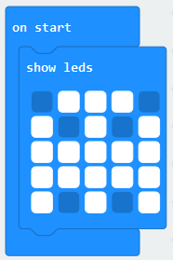

|  |  |  |  |  |
| --- | --- | --- | --- | --- |
|  |  |  |  |  |
|  |  |  |  |  |
|  |  |  |  |  |
|  |  |  |  |  |
|  |  |  |  |  |

Complete binary code: _______________________________________________________________________________

## You should now create your own bitmap by shading in your chosen pixels. Write the binary code below.

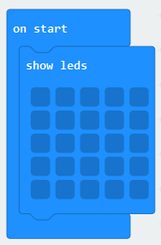

|  |  |  |  |  |
| --- | --- | --- | --- | --- |
|  |  |  |  |  |
|  |  |  |  |  |
|  |  |  |  |  |
|  |  |  |  |  |
|  |  |  |  |  |

Complete binary code: _______________________________________________________________________________

## Extension

You should now try to create a bitmap which has four colours. Each pixel will therefore need two binary digits. Complete the codes below initially to tell the computer what colour each unique code is:

00 = 01 = 10 = 11 =



|  |  |  |  |  |
| --- | --- | --- | --- | --- |
|  |  |  |  |  |
|  |  |  |  |  |
|  |  |  |  |  |
|  |  |  |  |  |
|  |  |  |  |  |